Press release

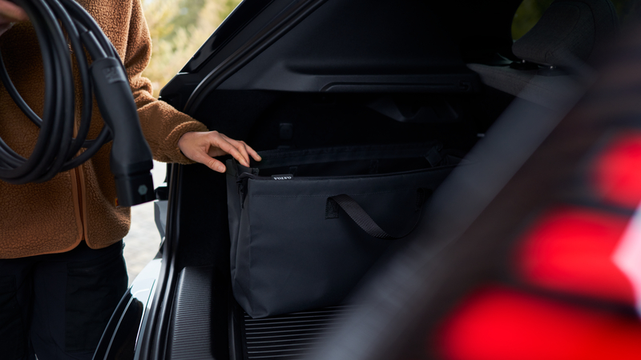
The habits that help EV owners get more from every charge

The gap between an electric car's quoted range and the range it delivers is mostly not the car. It is speed, temperature and habit and two of those are within the driver's control.
Speed is the largest single factor. Air resistance climbs steeply with velocity and an EV feels it more acutely than a petrol car because there is no engine efficiency curve working in the opposite direction. In short, a petrol engine runs better the harder it works, which hides some of the cost of speed. An electric motor is already near its best, so nothing is hidden. The difference between 120km/h and 130km/h on the N1 is more meaningful to your remaining range than almost anything else you will do that day.
Regenerative braking is the second lever. Lifting off early and letting the car slow itself recovers energy that friction braking throws away as heat. In stop-start traffic, where a combustion car is at its worst, an electrified vehicle is at its most efficient, provided the driver anticipates rather than reacts.
Pre-conditioning matters more than most owners realise. Heating or cooling the cabin while the car is still plugged in draws from the wall rather than the battery. On a cold Highveld morning that is several kilometres of range you keep.
"Most of this is just smoother driving," says Vusi Machie, Product and Pricing Manager at Volvo Car South Africa. "The car rewards someone who looks further ahead. That was true before electrification. It is simply easier to measure now."
Charging habits are the other half. For daily use, most manufacturers suggest keeping the battery between roughly 20 and 80% than routinely charging to full, and charging overnight at home on the lowest tariff available. Rapid public charging is best kept for journeys that need it.
Owners whose vehicles are subject to an active service action should follow the specific guidance issued to them directly, which takes precedence over any general advice.
Planning helps too. Setting a charging stop as a destination lets the car pre-condition the battery on approach, so it arrives at a temperature that can accept power quickly. Arriving with a cold pack is one of the more common reasons a charge takes longer than expected.
"None of this is about driving carefully in the sense of driving slowly," says Machie. "It is about spending energy where you want it rather than where the car loses it by default."
The technology does most of the work. The remainder is habit, and habit is the part that compounds.
<ends>

