For Immediate Release
Honda Wing Road Tour 2026
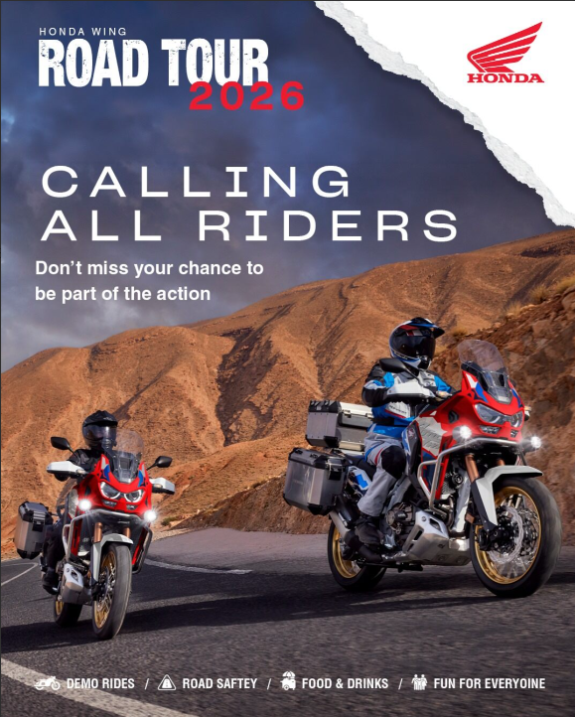
2026: Honda Wing Road Tour
- Honda Motor Southern Africa, through the Honda Wing Dealership network has begun the Honda Wing Road Tour 2026 - offering Demo Rides across 8 key Honda Motorcycle Models.
- On show are the Honda Africa Twin CRF1100 & Adventure Sport; Transalp XL750; Hornet CB750; Hornet CB1000SP; NC750X; NX500; CRF300 Rally, featured across selected dealerships nationwide.

Following the success and excitement of last year’s nationwide tour, Honda Motor Southern Africa is proud to announce the return of the Honda Wing Road Tour for 2026, which has already begun with Honda Wing Randburg (Biker’s Warehouse), Honda Wing Boksburg, Honda Wing Centurion and Honda Wing the Glen (Zeemans Motorcycles) with a substantial customer turnout.
Bigger, bolder, and ready for another year on the road, the tour will once again bring together riders, adventure enthusiasts, existing Honda customers, and prospective customers across 14 locations nationwide. The Honda Wing Road Tour has quickly become a standout event on the local motorcycle calendar, celebrating the passion, freedom, and sense of community that define the Honda riding lifestyle.

A COMMITMENT TO SAFETY, QUALITY, AND RELIABILITY
At Honda, safety, durability, quality, and reliability are at our core. Our motorcycles combine advanced technology, durable designs, and top safety features for a thrilling yet secure ride. From rugged adventure bikes to sleek urban models, the versatility of our bike range meets every rider’s needs. Each stop on the tour will feature demo ride experiences across 8 Honda models.

FEATURED HONDA MODEL LINEUP
(Subject to change)
- Africa Twin CRF1100
- Africa Twin CRF1100 Adventure Sport
- Transalp XL750
- Hornet CB750
- Hornet CB1000SP
- NC750X
- NX500
- CRF300 Rally
- All-New Honda CB1000GT

Soon to join the Honda Wing Road Tour will be models that include new Honda E-Clutch Technology which features the world’s first electronic clutch for motorcycles, offering customers effortless starts and stops, smoother gear shifts and less fatigue while still being fully manual.

HONDA WING ROAD TOUR 2026 SCHEDULE
(Subject to change)
- 30 MAY Honda Wing Randburg
- 6 JUN Honda Wing Boksburg
- 20 JUN Honda Wing Centurion
- 4 JUL Honda Wing The Glen
- 18 JUL Honda Wing Rivonia
- 1 AUG Honda Wing Pietersburg
- 8 AUG Honda Wing Nelspruit
- 22 AUG Honda Wing Bloemfontein
- 29 AUG Honda Wing Upington
- 5-12 SEPT NAMPO Cape event
- 19 SEP Honda Wing Cape Town / Tygerberg / Worcester
- 3 OCT Honda Wing George
- 17 OCT Honda Wing East Cape
- 7 NOV Honda Wing East London
- 21 NOV Honda Wing RBS Pinetown
- 5 DEC Honda Wing Richard Bay

“The response to last year’s Road Tour was incredible, and we’re excited to bring it back for 2026” said Riaan Fourie, Head of the Honda Motorcycle Division at Honda Motor Southern Africa. “We have already held our Randburg, Boksburg, Centurion and The Glen Road Tours which had a great turnout from local riders, who enjoyed their opportunity to ride and experience the latest in the Honda Motorcycle lineup.”

Honda Wing South Africa is dedicated to delivering premium motorcycles that combine durability, quality and reliability. With a strong focus on adventure, touring, and rider experience, Honda encourages all riders to attend at their nearest dealership.

Find your nearest Honda Wing dealership here: https://www.honda.co.za/motorcycles/find-a-dealer
ENDS

Issued by:
Sinead Pillay
Brand: Project Manager
The Motorcycle Division
Email: sinead.pillay@honda-eu.com

